Riverdale
Middle School
Discipline Policy

Expectations
1. Follow instructions and work to the best of your ability
2. Keep hands, feet, and objects to yourselves
3. Treat peers and staff with respect
4. Use technology according to GMSD policy.
5. Follow all GMSD policies and Riverdale rules and expectations.
6. Arrive to class on time with all necessary materials

Consequences
1. Verbal Warning
2. Conduct mark (parent email/impending detention)
3. Conduct mark (parent email/detention)
4. Conduct slip (parent email/parent conference)
5. Conduct slip (office referral)

* Severe behavior results in immediate referral to office

Conduct Grades Rewards:
E = 0 slips 1. Praise
S = 1-2 slips 2. Emails/phone calls home
N = 3-4 slips 3. Teacher Choice rewards
U = 5+ slips

*There are no G’s for conduct in middle school.
Please return this sheet to school and keep the first page for your records.

This year, instead of a conduct slip being sent home that must be signed and returned, we will be notifying parents through email correspondence from the student. Please make sure you have a current working email address in your Skyward account as this is the email that will be used for communication. Example of email conduct notification:
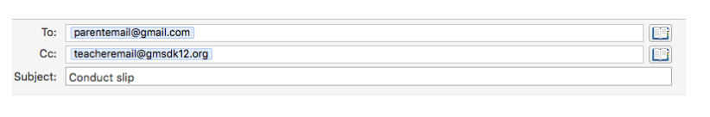

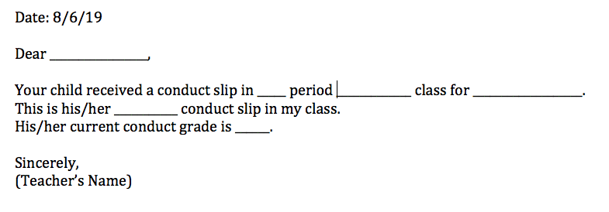

______ I have read the middle school discipline policy and discussed it with my
child.
_____ I have checked/updated my email in Skyward.

Date: ______________________

Student Signature: ______________________________
Parent Signature: ______________________________

